What is DNS?
DNS = Domain Name System
It’s like the phonebook of the internet.
It translates domain names (like www.google.com) into IP addresses (like 142.250.195.78), which computers use to communicate.

📱 Real-Life Analogy: Phonebook or Contact List
Imagine this:
- You want to call your friend Lokesh.
- You don’t remember his phone number.
- So, you open your contacts app and just tap on Lokesh.
➡️ Your phone automatically looks up Lokesh's number and dials it.
That’s exactly what DNS does on the internet!

💡 Real-Life Web Example:
Let’s say you open a browser and type:
www.facebook.com
Here’s what happens behind the scenes:
- Browser asks DNS – "Hey, what is the IP address of www.facebook.com?"
- DNS replies: "157.240.22.35"
- Your browser connects to 157.240.22.35 and loads Facebook.
So, you never need to remember or type the IP!

🧠 Why DNS is Important?
- Easy to remember names (google.com vs 142.250.195.78)
- Helps browsers, apps, and users find websites
- Allows companies to change servers without changing the domain

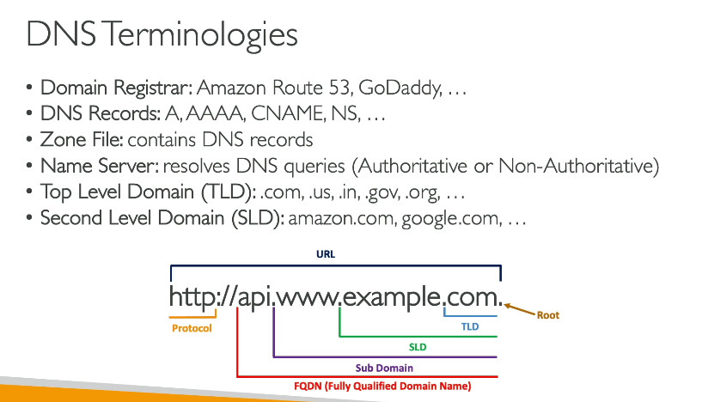
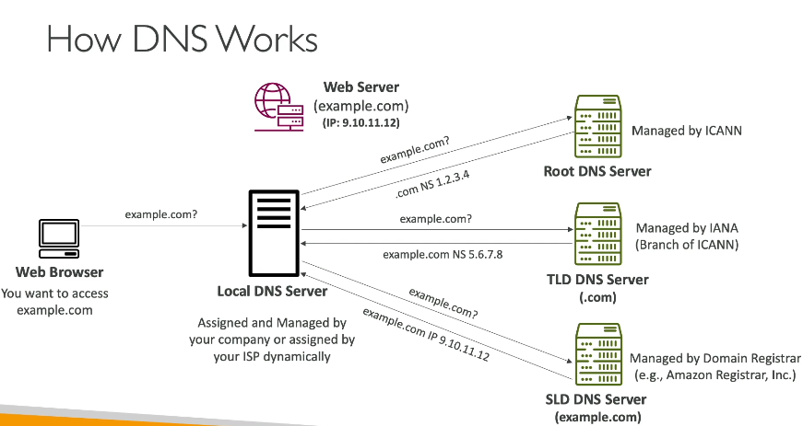

What is Route 53?
Amazon Route 53 is AWS’s scalable and highly available DNS and domain name service.
Think of it as:
“The traffic controller of the cloud.”
It helps you:
- Register domain names
- Route users to applications
- Check the health of your web resources

🧩 Why the name "Route 53"?
- “Route” – because it routes internet traffic.
- “53” – because DNS uses port 53 (TCP/UDP).

🛠️ Core Features of Route 53:
Feature | Purpose
Domain Registration | Buy and manage domain names directly in AWS.
DNS Service | Resolve domain names to IP addresses.
Health Checks | Monitor endpoints and route traffic only to healthy resources.
Traffic Flow (Routing Policies) | Control how users are routed (geo, latency, failover, etc.).
Integration with other AWS services | Works smoothly with EC2, ELB, S3, CloudFront, etc.

⚙️ How Route 53 Works (Simple Flow):
- User enters: www.myclientproject.com
- DNS resolver contacts Route 53
- Route 53 looks up DNS record for your domain
- Returns the correct IP address (or load balancer)
- User is routed to your application server

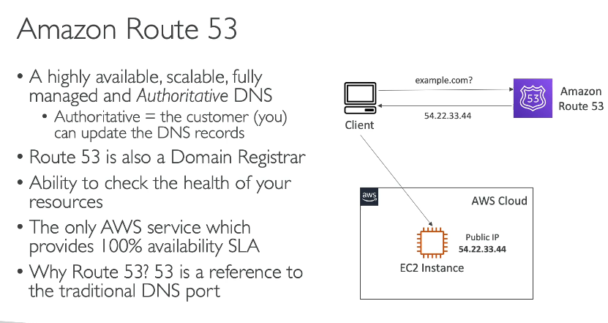
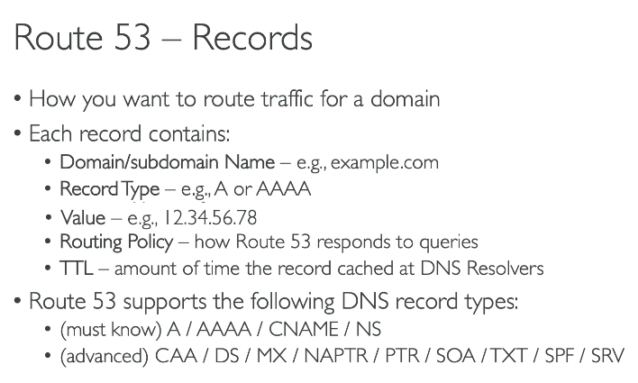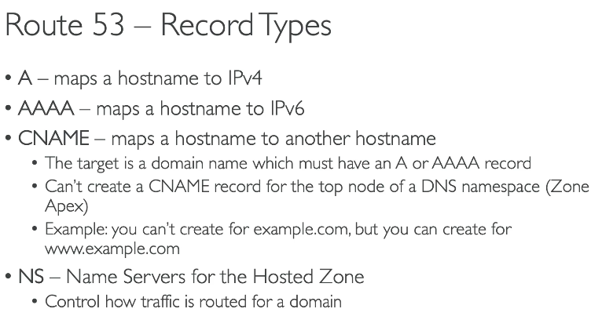
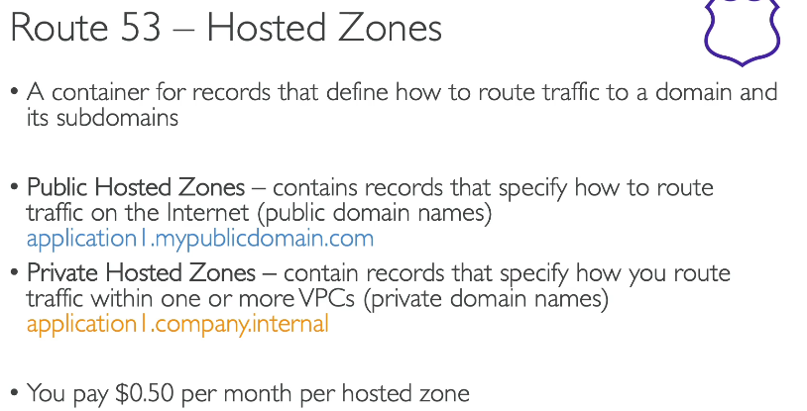
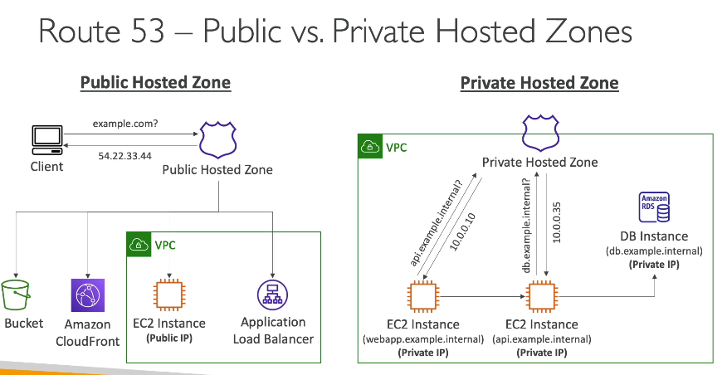

What is TTL in Route 53?
TTL = Time To Live
It’s the amount of time (in seconds) that DNS resolvers should cache (remember) the DNS record before checking again with Route 53.

🔁 Real-Life Analogy:
Imagine you’re telling your friend:
"This phone number is valid for the next 5 minutes. After that, call me again to check if it changed."
That “5 minutes” is the TTL.

📦 Where You See TTL in Route 53:
When you create or update a DNS record (like an A, CNAME, or MX record), you’ll see a TTL field.
Record Type: A
Value: 20.188.228.44
TTL: 300 seconds (default)
This means:
Resolvers will cache this record for 5 minutes before checking again.

⏱️ Common TTL Values:
TTL (Seconds) | Meaning | Use Case
60 (1 min) | Very short | Good for temporary testing or dynamic changes
300 (5 min) | Default | Balance between performance and flexibility
3600 (1 hr) | Longer cache | For stable records (like static sites)
86400 (1 day) | Long cache | For rarely changing DNS (e.g., email MX records)

⚡ Why TTL Matters:
- Performance: Higher TTL = fewer DNS lookups = faster response
- Flexibility: Lower TTL = faster propagation of changes (e.g., IP updates)
- Traffic Control: TTL works with failover and routing policies in Route 53

🧪 Example:
You switch your frontend app IP from 20.188.228.44 to 20.10.5.1:
- If TTL is 60, change takes effect quickly (~1 min)
- If TTL is 86400, users may still hit the old IP for up to 24 hours
😱That’s why setting a short TL before planned DNS changes is a smart move!

🔐 Bonus: In Failover Routing
When using failover policies, Route 53 can:
- Monitor the health of primary resources
- Automatically switch to backup if health checks fail
- TTL controls how quickly DNS caches respect that switch

✅ Tips:
- Set short TTL (60-300) during changes or testing
- Set long TTL (3600+) for stable services to reduce DNS traffic
- Always update TTL before major migrations or IP changes

What Are They?
Record Type | Purpose
CNAME | Maps a domain name to another domain name
Alias | AWS-specific – behaves like CNAME but can point to AWS resources (like Load Balancers, CloudFront, S3, etc.) and is faster

🔁 Real-World Analogy:
- CNAME is like saying:
"Go to this address: myapp.example.com, which is the same as appserver123.otherdomain.com."
- Alias is like saying:
"Go to my house, but the address changes based on traffic — AWS figures it out for you."

🔍 Key Differences:
Feature | CNAME | Alias
Points to | Another domain name | AWS resource (like ELB, CloudFront) or domain
Root domain support (e.g., example.com) | ❌ Not allowed (only subdomains) | ✅ Allowed
Works outside AWS | ✅ Yes | ❌ AWS only
DNS query charges | ✅ Standard charge | ✅ No extra charge for AWS resources
Evaluation | Client-side DNS resolver | AWS-managed alias resolution

💡 Real-Life Use Cases:
✅ Use CNAME when:
- You want to map:
www.myclient.com ➝ myclient.herokuapp.com
- You’re pointing to a third-party service or another domain.

✅ Use Alias when:
- You want to map:
cpp
myclient.com ➝ AWS Load Balancer, S3 static website, CloudFront, etc.
- You're working within AWS and want better performance and root domain support.

⚠️ Important Rule:
- You cannot create a CNAME at the root domain level (example.com) — it's against DNS rules.
- But Alias records can be used at the root level in Route 53.

👨‍💻 Example:
Using CNAME:
www.himwasnik.in ➝ himanshu.herokuapp.com
Using Alias:
himwasnik.in ➝ AWS Load Balancer (ALB)

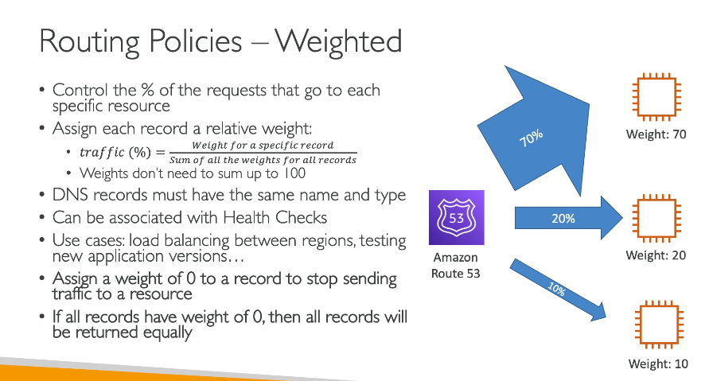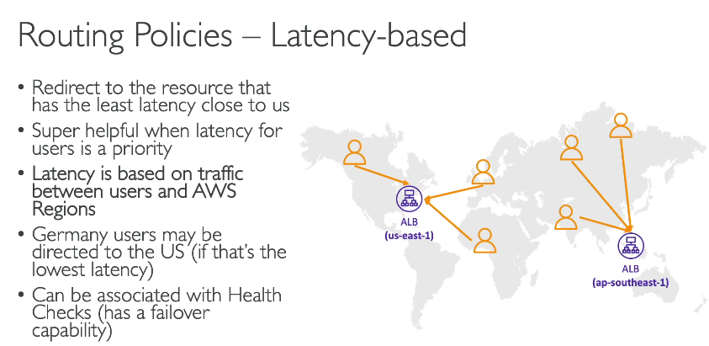

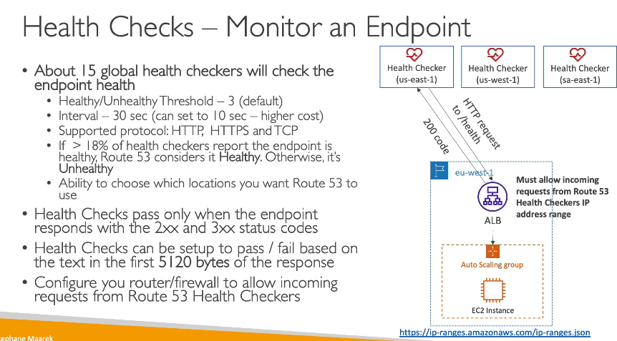
Failover Routing
➤ Primary + Secondary setup. Uses health checks
🧠 Example:
- Primary: app-backend-primary.com (Healthy)
- Secondary: app-backend-backup.com (Unhealthy)
📦 Use Case:
- High availability apps
- Automatic traffic redirection if main server fails

5. Geolocation Routing
➤ Route users based on their country or region
🧠 Example:
- Users from India → indian-version.himwasnik.in
- Users from USA → us-version.himwasnik.in
📦 Use Case:
- Region-specific content/language
- Legal/compliance needs

6. Geoproximity Routing (with Traffic Flow)
➤ Similar to geolocation, plus distance control using bias
🧠 Example:
Push users in Asia slightly closer to Singapore region, even if India is nearer.
📦 Use Case:
- Fine-tuned location-based routing
- Cloud optimization
🛑 Note: Needs Route 53 Traffic Flow
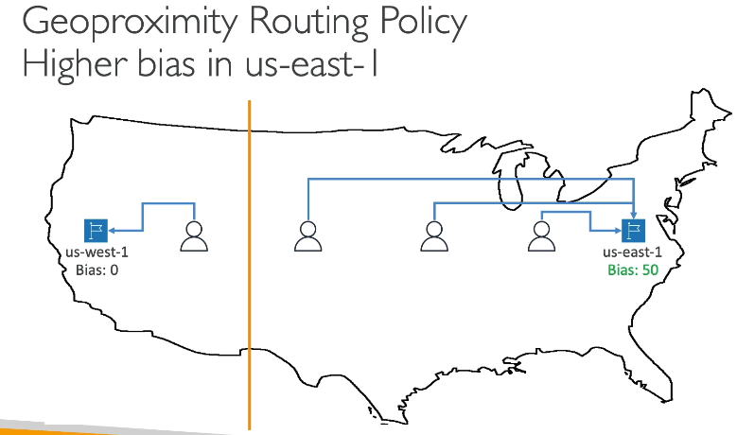
7. Multivalue Answer Routing
➤ Returns multiple IPs (like a round-robin)
Also supports health checks
🧠 Example:
- Returns 3 healthy IPs for api.himwasnik.in
📦 Use Case:
- Basic load balancing
- Redundancy
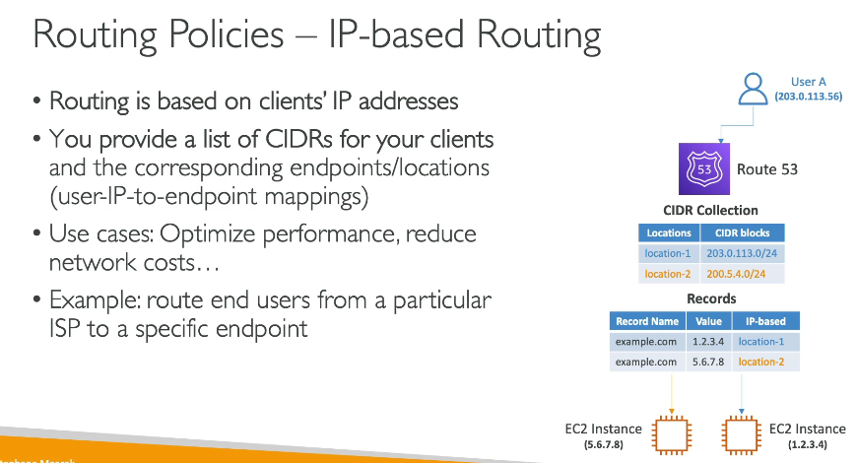

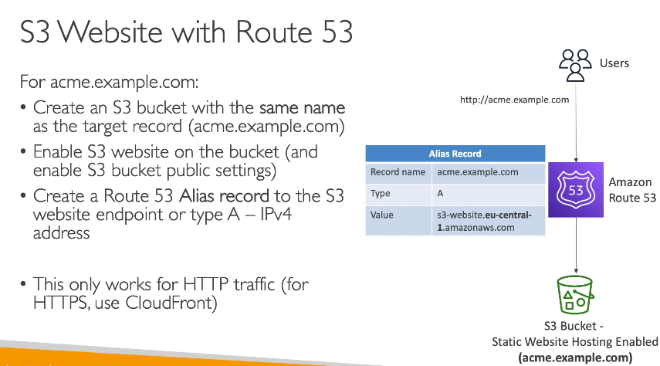
Steps Overview:
- Create & configure S3 bucket
- Enable static website hosting
- Upload your website files
- Set correct permissions
- Create a Route 53 hosted zone (if not done)
- Point your domain to S3 using Route 53

What is Route 53 Resolver?
Route 53 Resolver is Amazon's DNS service that helps resolve DNS queries between your AWS VPC and on-premises network.
It provides:
- Outbound DNS resolution – AWS → On-premises
- Inbound DNS resolution – On-premises → AWS

💡 Why Use Route 53 Resolver?
When you have a hybrid environment (AWS + On-premises via VPN/Direct Connect), normal DNS doesn’t resolve private AWS resources or internal corporate resources across environments.
That’s where Resolvers come in.

🏗️ Architecture Overview
pgsql
+-------------------+ +---------------------+
| On-Prem Network | | AWS VPC |
| DNS: corp.local | <---> | DNS: ec2.internal |
+-------------------+ +---------------------+
▲ ▲
| |
Inbound Resolver Outbound Resolver
(for AWS-hosted names) (for corp.local names)

🧭 Two Key Resolver Directions
1. Outbound Resolver (AWS → On-prem)
- AWS VPC needs to resolve on-prem DNS like db.corp.local
- Create a Outbound Endpoint in Route 53 Resolver
- Forward queries to on-prem DNS IP
👉 Useful for apps in AWS needing access to internal names

2. Inbound Resolver (On-prem → AWS)
- On-prem apps want to resolve AWS private records (e.g., ip-10-0-1-5.ec2.internal)
- Create an Inbound Endpoint
- Set your on-prem DNS to forward AWS domain queries to that IP
👉 Enables your office/data center users or services to access private AWS resources by name

🔧 Setup Steps Summary
✅ Outbound Resolver
- Go to Route 53 → Resolver → Endpoints
- Create Outbound Endpoint
- Choose 2+ subnets (across AZs for HA)
- Provide on-prem DNS server IPs (e.g., 192.168.1.10)
- Create Rules to forward corp.local to outbound endpoint

✅ Inbound Resolver
- Create Inbound Endpoint
- Assign subnets & security groups
- Get the IP addresses of inbound resolver
- On your on-prem DNS (like Windows AD), create a forwarding rule to these IPs for AWS domains like ec2.internal

🧠 Hybrid DNS = Seamless DNS Across AWS + On-Prem
Hybrid DNS means using Route 53 + your existing DNS (like Windows DNS, BIND, etc.) to:
- Resolve internal names in both directions
- Avoid public exposure
- Keep consistent naming across hybrid infra

💼 Real-Life Use Case
You host:
- App frontend in AWS
- DB in on-premises
- Need both to resolve each other’s names securely
✔️ Use Route 53 Outbound Resolver in AWS to forward queries to your on-prem DNS
✔️ Use Inbound Resolver so on-prem systems can resolve AWS hostnames
